**MEMORY TYPES**

**Computer Memory**

**Definition**:  
Computer memory is a system of components in a computer that stores data and instructions for processing. It enables data to be stored, retrieved, and manipulated, acting as a bridge between the CPU and storage devices.

**Composition**:  
Composed of electronic circuits such as semiconductors and transistors. Classified into:

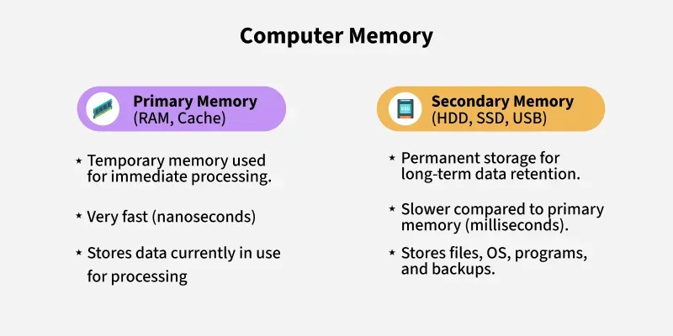

**Primary memory** (RAM, Cache) – fast and volatile.

**Secondary memory** (HDDs, SSDs) – slower but non-volatile.

**Tertiary/Backup memory** – external devices used for storage backups (e.g., external HDDs, cloud storage).

**Types**:

Volatile Memory: Data is lost when power is off (e.g., RAM).

Non-Volatile Memory: Data is retained even when power is off (e.g., ROM, SSDs).

Read/Write Memory: Can be read from and written to (e.g., RAM).

Read-Only Memory: Data can only be read (e.g., traditional ROM).

***Memory hierarchy pyramid***

(Registers → Cache → RAM → HDD/SSD)

**Advantages**:

* Enables multitasking and fast data processing.
* Temporary and permanent data storage options.
* Supports CPU operations efficiently.

**Disadvantages**:

* Primary memory is expensive and limited in capacity.
* Volatile memory loses data during power loss.

**Troubleshooting**:

Use memory diagnostics tools (e.g., Windows Memory Diagnostic).

Check for faulty modules, overheating, or improper installation.

**RAM (Random Access Memory)**

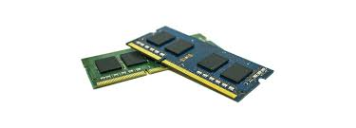

**Definition**:  
RAM is a volatile memory that temporarily stores data and programs currently in use. It allows read/write access and directly interacts with the CPU for quick operations.

**Composition**:  
Made up of millions of capacitors and transistors arranged in a grid. It operates on electric charges to represent binary data (0s and 1s).

**Types**:

**DRAM (Dynamic RAM)**: Most common, needs constant refreshing.

**SRAM (Static RAM)**: Faster and more reliable but costlier; used in cache.

**DDR SDRAM (DDR2, DDR3, DDR4, DDR5)**: Double Data Rate versions with varying speed and efficiency.

**Advantages**:

* Fast data access for active applications.
* Boosts system performance and multitasking.

**Disadvantages**:

* Volatile – data is lost when the system is off.
* Limited capacity compared to storage drives.

**Troubleshooting**:

Slow performance or system crashes may indicate bad RAM.

Test with software like MemTest86 or replace faulty RAM sticks.

**ROM (Read-Only Memory)**

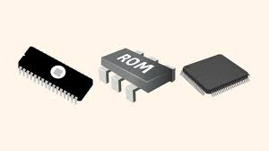

**Definition**:  
ROM is a non-volatile memory that permanently stores firmware and system instructions. It is essential for booting up and basic hardware control.

**Composition**:  
Uses integrated circuits that retain data without power. Originally hardwired but now programmable.

**Types**:

**PROM (Programmable ROM)** – written once post-manufacture.

**EPROM (Erasable PROM)** – can be erased with UV light and reprogrammed.

**EEPROM (Electrically Erasable PROM)** – can be reprogrammed with electricity.

**Advantages**:

* Permanent storage for BIOS and system firmware.
* Secure – cannot be modified by malware.

**Disadvantages**:

* Limited modifiability.
* Slower access compared to RAM.

**Troubleshooting**:

Boot failure may point to corrupt ROM.

May require chip replacement or motherboard service.

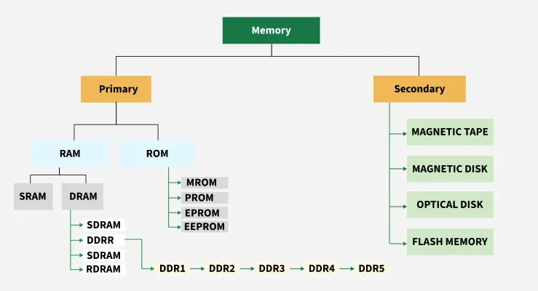

**Cache Memory**

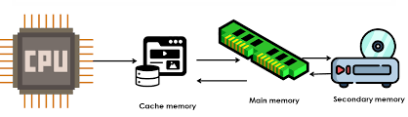

**Definition**:

It is a type of high-speed semiconductor, small-sized volatile memory that can help the CPU run faster. Between the CPU and the main memory, it serves as a buffer. It is used to store the data and programs that the CPU uses the most frequently.

**Composition**:  
Built using **SRAM** (Static RAM) for faster speed. Often embedded directly in the processor chi

**Types**:

**L1 Cache**: Smallest, fastest, built into CPU core.

**L2 Cache**: Larger, slightly slower, shared by CPU cores.

**L3 Cache**: Even larger, shared across all cores.

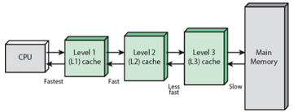

**Advantages**:

* It is faster than the main memory.
* When compared to the main memory, it takes less time to access it.
* It keeps the programs that can be run in a short amount of time.
* It stores data for temporary use.

**Disadvantages**:

* Because of the semiconductors used, it is very expensive.
* The size of the cache (amount of data it can store) is usually small.

**Troubleshooting**:

Rarely fails independently; CPU replacement needed if damaged.

BIOS/firmware updates may optimize cache performance.

**Virtual Memory**

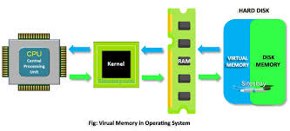

**Definition**:  
Virtual memory is a memory management technique that uses secondary storage (like a hard drive or SSD) to extend the available physical memory (RAM). It allows a computer to run more programs or larger programs than it could normally with the limited RAM it has.

**Composition**:  
Implemented via a **page file** or **swap space**. The OS moves data between RAM and virtual memory to manage workloads.

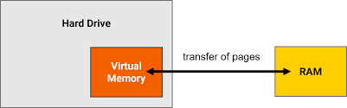

**Types**:

**Paging**: Memory is divided into fixed-size pages.

**Segmentation**: Divided based on program logic (e.g., code, stack, data).

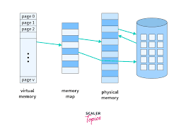

**Advantages**:

* Expands usable memory.
* Prevents out-of-memory crashes.

**Disadvantages**:

* Slower than physical RAM.
* Can lead to frequent disk reads/writes (thrashing).

**Troubleshooting**:

Increase physical RAM to reduce dependence.

Adjust page file size via OS settings for better performance.

**Flash Memory**

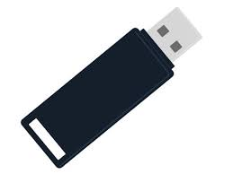

**Definition**:  
Flash memory is a non-volatile memory used for storing data in devices like USB drives, SSDs, memory cards, and embedded systems.

**Composition**:  
Based on **floating-gate transistors** that trap electrons to store data. Two main types: **NAND -NOT AND** (high capacity, used in SSDs) and **NOR- NOT OR** (used in firmware).

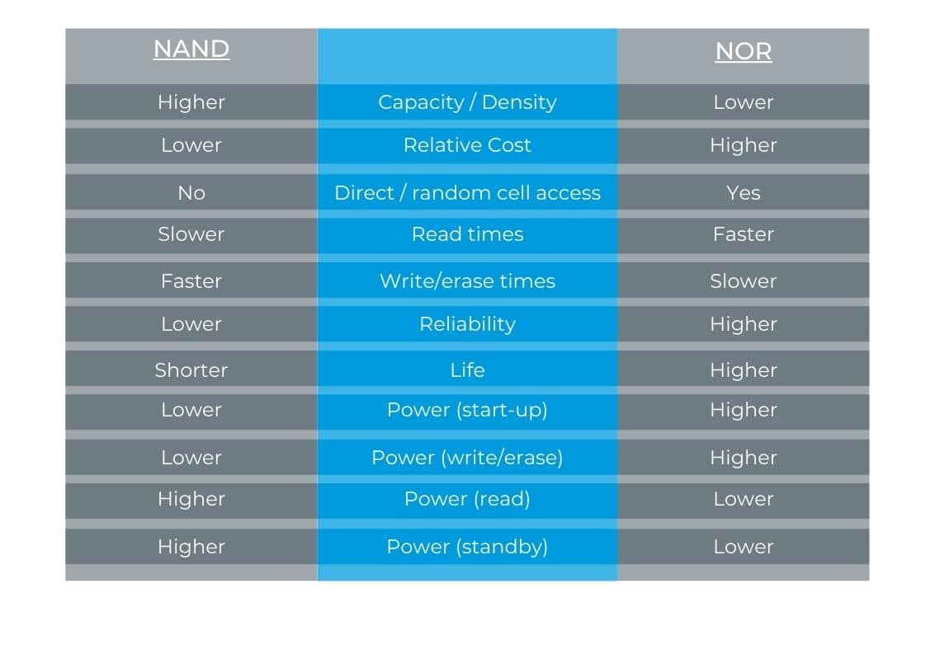

**Types**:

**SLC (Single-Level Cell)** – 1 bit/cell, fast, durable.

**MLC (Multi-Level Cell)** – 2 bits/cell, higher capacity.

**TLC (Triple-Level Cell)** – 3 bits/cell, cheaper, less durable.

**Advantages**:

* Fast read/write speeds.
* Portable, energy-efficient, no moving parts.
* Ideal for mobile and embedded devices.

**Disadvantages**:

* Limited write/erase cycles (wear out over time).
* More expensive per GB than HDDs.

**Troubleshooting**:

* Use tools to monitor SSD health (e.g., CrystalDiskInfo).
* Back up data frequently to prevent data loss.

**Summary**

Computer memory is vital to system performance. Various types—RAM, ROM, Cache, Virtual, and Flash memory—serve different purposes based on speed, volatility, and use cases. Understanding their roles helps in system design, troubleshooting, and optimizing computing resources.